**JAVA**

Java is an [object-oriented](https://www.javatpoint.com/java-oops-concepts), class-based, concurrent, secured and general-purpose computer-programming language.   
Java is a **programming language** and a **platform**. Java is a high level, robust, object-oriented and secure programming language.  
Java was developed by *Sun Microsystems* (which is now the subsidiary of Oracle) in the year 1995. *James Gosling* is known as the father of Java. Before Java, its name was *Oak*. Since Oak was already a registered company, so James Gosling and his team changed the name from Oak to Java.

**Java OOPs Concepts (Object-Oriented Programming System)**

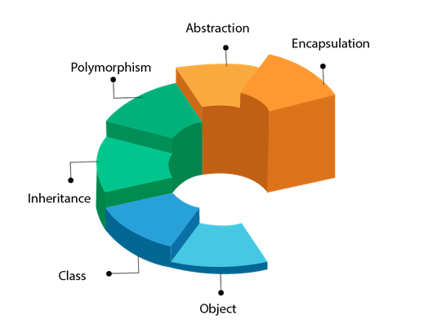

**Object**

* *Any entity that has state and behaviour is known as an object. For example, a chair, pen, table, keyboard, bike, etc. It can be physical or logical.*
* *Example: A dog is an object because it has states like colour, name, breed, etc. as well as behaviours like wagging the tail, barking, eating, etc.*

**Class**

* *Collection of objects* is called class. It is a logical entity.
* A class can also be defined as a blueprint from which you can create an individual object. Class doesn't consume any space.

Inheritance

* *When one object acquires all the properties and behaviours of a parent object, it is known as inheritance. It provides code reusability. It is used to achieve runtime polymorphism.*

**Polymorphism**

* *If one task is performed in different ways, it is known as polymorphism. For example: to convince the customer differently, to draw something, for example, shape, triangle, rectangle, etc.*
* *In Java, we use method overloading and method overriding to achieve polymorphism.*
* *Another example can be to speak something; for example, a cat speaks meow, dog barks woof, etc.*

**Abstraction**

* *Hiding internal details and showing functionality is known as abstraction. For example phone call, we don't know the internal processing.*
* *In Java, we use abstract class and interface to achieve abstraction.*

**Encapsulation**

* *Binding (or wrapping) code and data together into a single unit are known as encapsulation. For example, a capsule, it is wrapped with different medicines.*
* *A java class is the example of encapsulation. Java bean is the fully encapsulated class because all the data members are private here.*



**Simple java program**

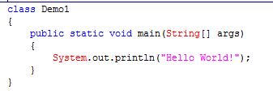

**Parameters used in First Java Program**

Let's see what is the meaning of class, public, static, void, main, String[], System.out.println().

**Class** - keyword is used to declare a class in Java.

**public**  - keyword is an access modifier that represents visibility. It means it is visible to all.

**Static** -  is a keyword. If we declare any method as static, it is known as the static method. The core advantage of the static method is that there is no need to create an object to invoke the static method. The main() method is executed by the JVM, so it doesn't require creating an object to invoke the main() method. So, it saves memory**.**

**Void -** is the return type of the method. It means it doesn't return any value.

**main  -** represents the starting point of the program.

**String[] args or String args[] -** is used for [command line argument](https://www.javatpoint.com/command-line-argument). We will discuss it in coming section.

**System.out.println() -** is used to print statement. Here, System is a class, out is an object of the PrintStream class, println() is a method of the PrintStream class.

**How to compile code**

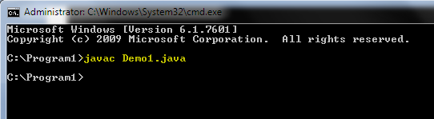

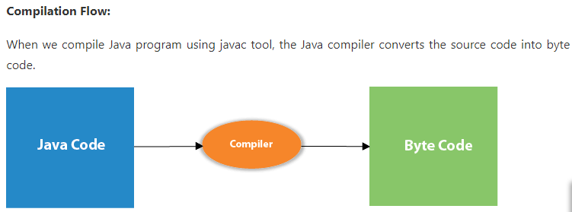

**How to execute program**

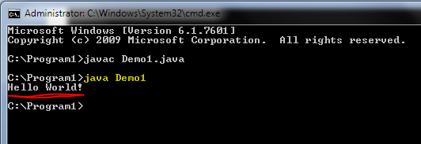

**How to set path in Java**

* There are two ways to set the path in Java:
  + - * 1. Temporary
      * 2. Permanent
* How to set the Temporary Path of JDK in Windows
  + - Open the command prompt
    - Copy the path of the JDK/bin directory
    - Write in command prompt: set path= copied_path

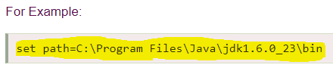

**Example :**

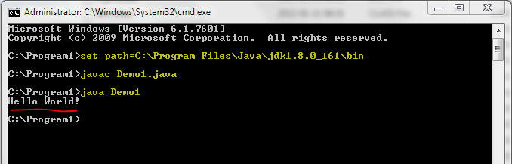

**How to set Permanent Path of JDK in Windows**

Go to MyComputer properties -> advanced tab -> environment variables -> new tab of user variable -> write path in variable name -> write path of bin folder in variable value -> ok -> ok -> ok

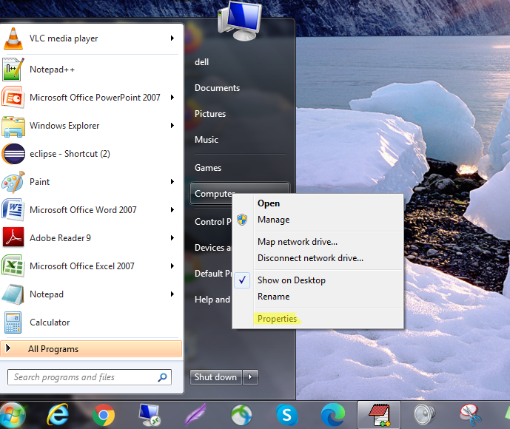

**Click on the advanced tab**

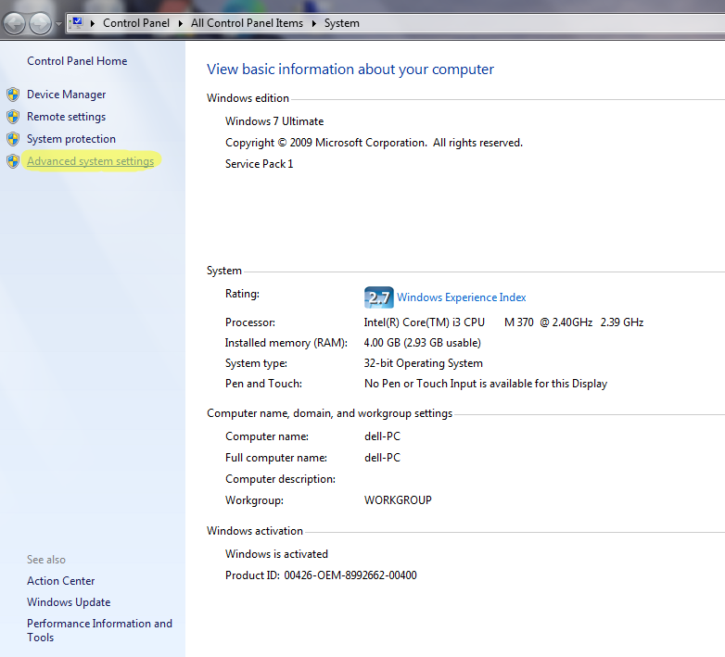

**Click on environment variables**

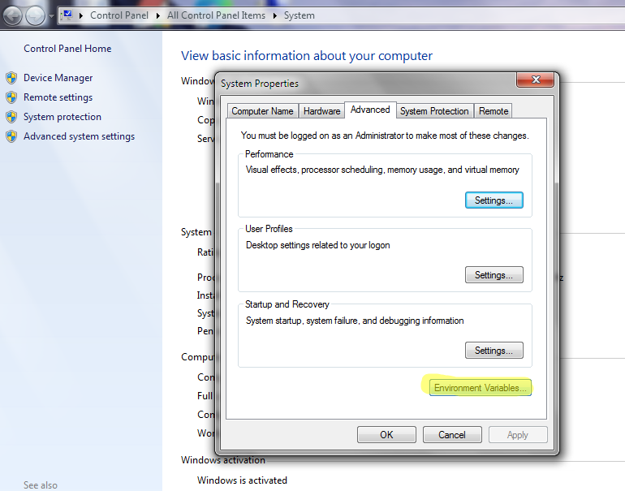

**Click on the new tab of user variables**

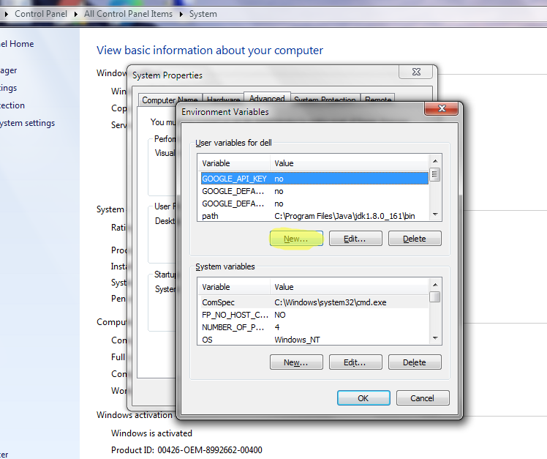

**Write the path in the variable name**

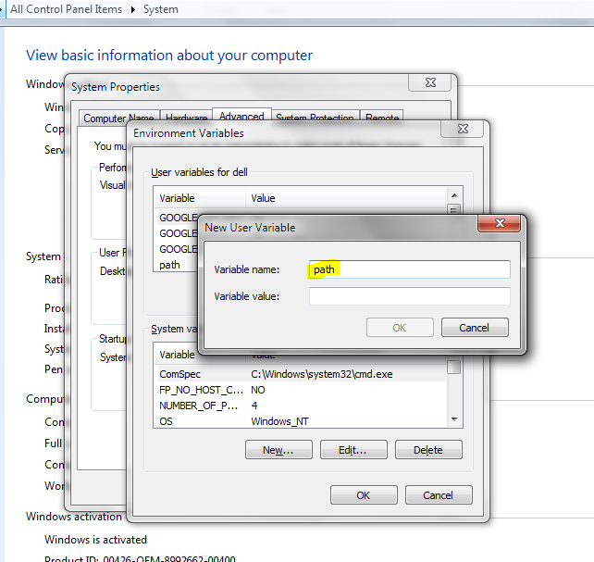

**Copy the path of bin folder**

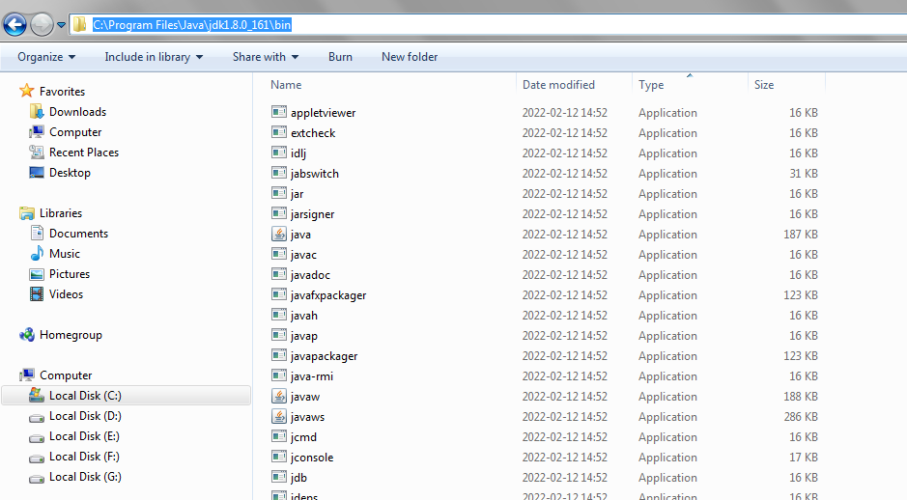

**Paste path of bin folder in the variable value**

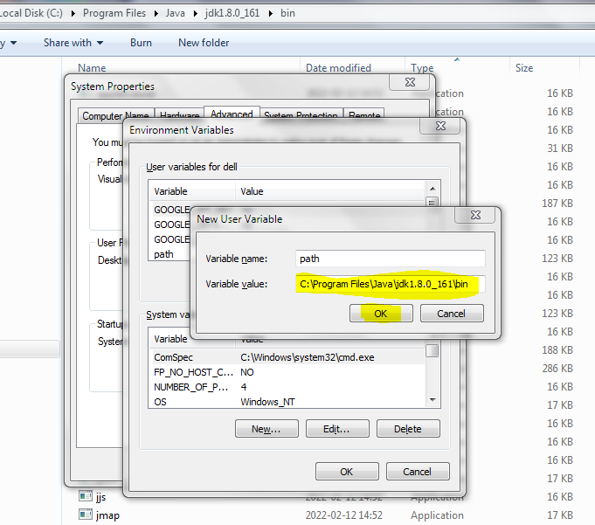

**Click on ok button**

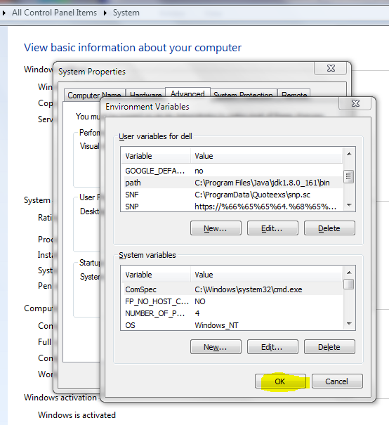

**Click on ok button**

